|  |  |
| --- | --- |
|  | xxxxICT – xxx  School of Information & Communication Technology  Trimester _, 202_  **Assignment Part 2:**  **Implementing a Database for _________** |

**ASSIGNMENT TITLE: _________________________________________________________**

**GROUP NUMBER: ______________________________________________________________**

|  |  |  |  |  |
| --- | --- | --- | --- | --- |
| **s-Number** | **Full name** | **Course Code** | **Contribution %** | **Signature**\* |
|  |  |  |  |  |
|  |  |  |  |  |
|  |  |  |  |  |
|  | **Total contributions** |  | **100%** |  |

\**Follow the note below.*

**PLAGIARISM**

Plagiarism: occurs when the work of another is represented, intentionally or unintentionally, as one's own original work, without appropriate acknowledgement of the author or the source. See more on [academic integrity](https://www.griffith.edu.au/academic-integrity) and [academic misconduct](https://www.griffith.edu.au/academic-integrity/academic-misconduct) pages on Griffith website.

Plagiarism is a serious offence. Refer to the [Griffith’s policy on Student Academic Misconduct](http://policies.griffith.edu.au/pdf/Student%20Academic%20Misconduct%20Policy.pdf).

|  |  |  |
| --- | --- | --- |
| Declaration  Except where appropriately acknowledged, this assignment is our own work, has been expressed in our own words and has not previously been submitted for assessment. We have also retained a copy of this assessment piece for our own records. | | |
| **Student 1:** | **Student 2:** | **Student 3:** |
| Name: _______________  Signature: ______________*  Date: _______________* | Name: _______________  Signature: ______________*  Date: _______________* | Name: _______________  Signature: ______________*  Date: _______________* |

\**Follow the note below.*

Note: All students in the group must sign & date on this first page.

# **Table of Contents**

[Generate a table of content with page numbers.]

Table of Contents 2

MySQL System Schema 3

SQL Queries for Database Creation in Task 1 4

SQL Queries For Data Insertion in Task 2 5

Reports on SQL Queries in Task 3 6

# 

# **MySQL System Schema**

[Insert the your system schema extracted from MySQL]

*Example system schema extracted from MySQL’s designer:*

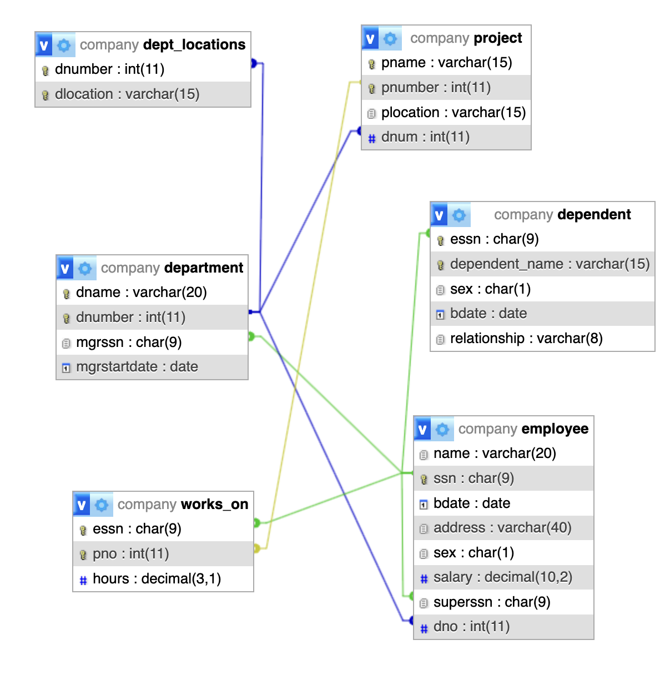

# **SQL Queries for Database Creation in Task 1**

[Insert the CREATE Query from the Create.txt below.]

|  |
| --- |
| /* Create & use database */  CREATE DATABASE IF NOT EXISTS xxx;  use xxx;  … |

# **SQL Queries For Data Insertion in Task 2**

[Insert the INSERT queries from the Insert.txt below]

|  |
| --- |
| INSERT… INTO… |

# **Reports on SQL Queries in Task 3**

[Place each SQL Query and its output table below.]

**Query 1:**

**Output table:**

**Query 2:**

**Output table:**

**Query 3:**

**Output table:**

**Query 4:**

**Output table:**

[Continue for all your queries in Task 3]